COMP 330/543 Tools and Models for Data Science
Part I Connect to the DB
You cannot connect to the server from outside of the Rice network. If you want to connect from off-campus or if you are using the Rice Guest wi-fi, you need to connect via VPN.
You can can find the instructions on how to install Rice’s VPN client in the following link:
https://kb.rice.edu/page.php?id=82263
Preferred Connection Method: Use a tool called DataGrip.
DataGrip is a nice tool, but it appears to be free only for 30 days. As a student, it seems possible to get a license that doesn't expire. See https://www.jetbrains.com/student/.
- Download and install data grip from the JetBrains website.
- Create a new project by going to File -> New -> New Project
- Then add a new Data Source by selecting File -> New -> DataSource -> Microsoft SQL Server (jTds). You can also use the ‘+’ sign that appears on the Database Explorer pane.
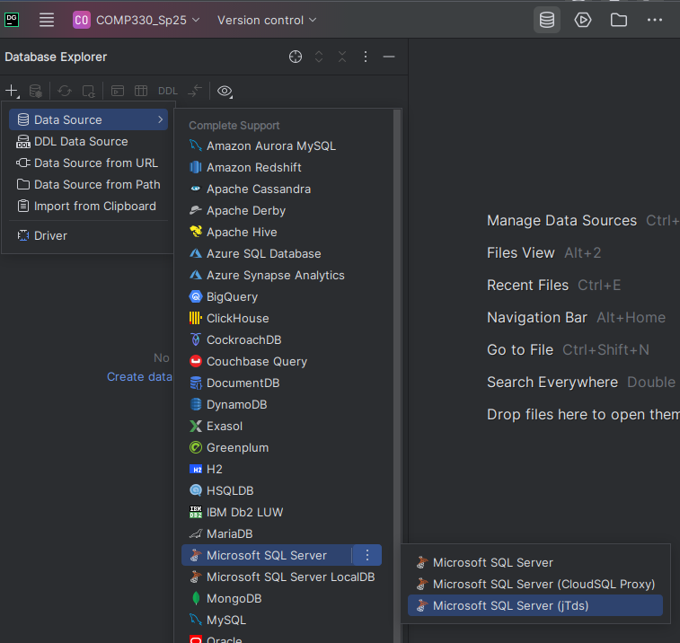
- Then set the fields as follows:
  - Host: classdb.ad.rice.edu,
  - Port: 1433
  - User: use your NetID, as well as your password.
  - Make sure the driver you have chosen is “Microsoft SQL Server (jTds)”; we have had some trouble with the other ones.
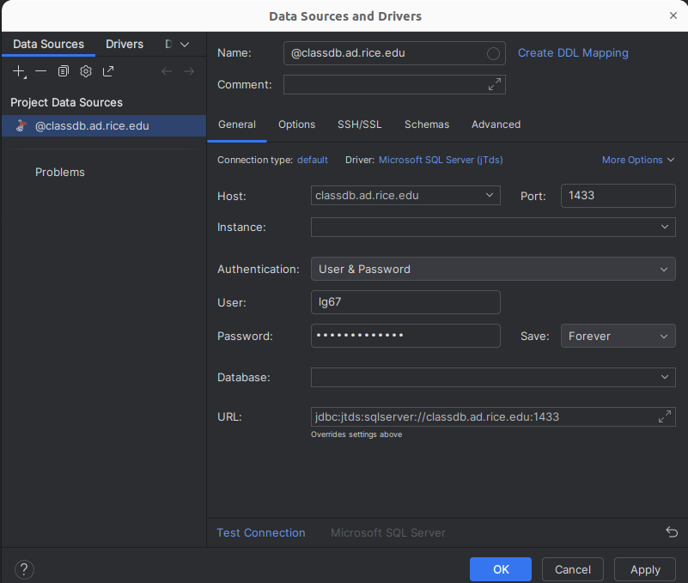
- Under the “Advanced” tab (right above host), you will add a new name “DOMAIN” and value “adrice”. Click the ‘Apply’ button at the bottom.
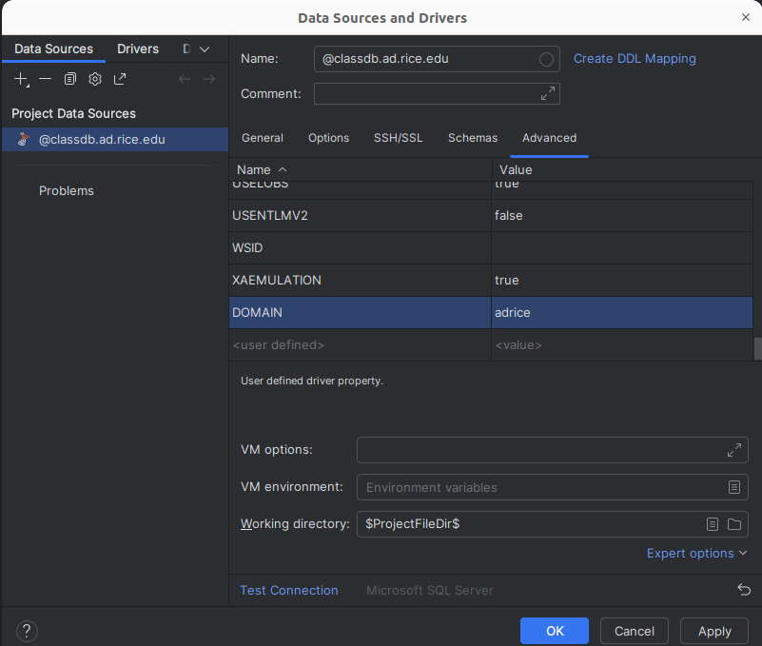
- Go back to the “General” tab and make sure that everything is configured correctly. Then click “Test Connection”. If it is greyed out, you may be missing a driver file.
  - Look at the bottom of the screen for “Download missing driver files” and click “Download”.
- If your connection is successful you will get a message like the following:
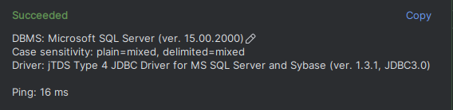
- After you get a successful connection, click OK. You should be ready to go. After you type SQL into the console, make sure to click the green button to run your SQL.

--------------------------------------------------
Part II Create and Populate the Database
IMPORTANT NOTE: Please note that after you connect to the class database (master), you should create your own database and execute operations on it (create tables, edit data, etc.) Otherwise, you will use the 'master' database which can be accessed by everyone.
The command for creating your own database is:
CREATE DATABASE mydb
USE mydb
'mydb' is just a placeholder name here. Instead, you should pick whatever name you want that uniquely identifies your database. Most people just use their NetID.
After that, all of your operations and commands will be under this database. Please also note that the database's name is global. So do not attempt to create a database with an existing name or use others’ databases.
You can see what database you are currently using in the right-hand side of the console pane:
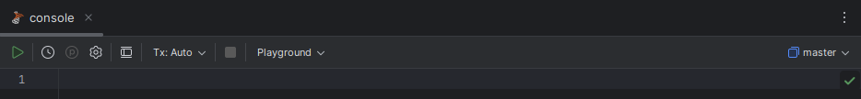
The example above is using the ‘master’ database. If you are also seeing this, simply click it to get a drop down menu where you can select your own database:
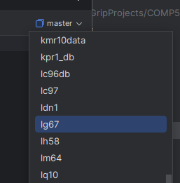
Please create a single database for your personal use.
Running Commands in DataGrip
- The way to run commands in DataGrip is to create/open a new console
- Type the SQL query(ies) into the console
- Highlight the query(ies) you want to run, and click the green arrow to run them.
You can delete the database with the following command:
DROP DATABASE mydb
In addition, you can use the following command to see all tables in your database
SELECT * FROM INFORMATION_SCHEMA.TABLES WHERE TABLE_TYPE = 'BASE TABLE'
After you create your database and add tables, you should see something like this (though your tables will be different!)
TABLE_CATALOG TABLE_SCHEMA TABLE_NAME TABLE_TYPE
mydb dbo CLIMBER BASE TABLE
mydb dbo CLIMBED BASE TABLE
mydb dbo PEAK BASE TABLE
mydb dbo PARTICIPATED BASE TABLE
Again, 'mydb' will be your own database's name.
Running the SQL scripts
In DataGrip, you don't necessarily have to type all of the SQL yourself.
- Select File -> Open and then open up the SQL file that you want to execute.
  - For example, open up "createtables.sql" (included in the SSWC.zip file you downloaded from Canvas) to access the SQL code that we've provided to create all of the tables.
- Select all of the text in the file, and then press the green button and it will execute.
- Once you have created the tables, you can run each of the SQL files, in sequence, to populate all of the database tables.

